VISVESVARAYA TECHNOLOGICAL UNIVERSITY

“Jnana Sangama”, Machhe, Belagavi, Karnataka-590018

Lab Experiment Record
Project Management with Git [BCS358C]
Submitted in partial fulfillment towards AEC of 3rd semester of

Bachelor of Engineering

in
Computer Science and Engineering
(Artificial Intelligence & Machine Learning)
Submitted by
SWATI

4GW24CI054

DEPARTMENT OF CSE (Artificial Intelligence & Machine Learning)
GSSS INSTITUTE OF ENGINEERING & TECHNOLOGY FOR WOMEN

(Affiliated to VTU, Belagavi, Approved by AICTE, New Delhi & Govt. of Karnataka)
K.R.S ROAD, METAGALLI, MYSURU-570016, KARNATAKA

(Accredited by NAAC)

2025-2026

Project Management with Git
Exp1: Setting Up and Basic Commands Initialize a new Git repository in a directory. Create a new file and add it to the staging area and commit the changes with an appropriate commit message.
Solution: To initialize a new Git repository in a directory, create a new file, add it to the staging area, and commit the changes with an appropriate commit message, follow these steps:
1. Open your terminal and navigate to the directory where you want to create the Git repository.
2. Initialize a new Git repository in that directory
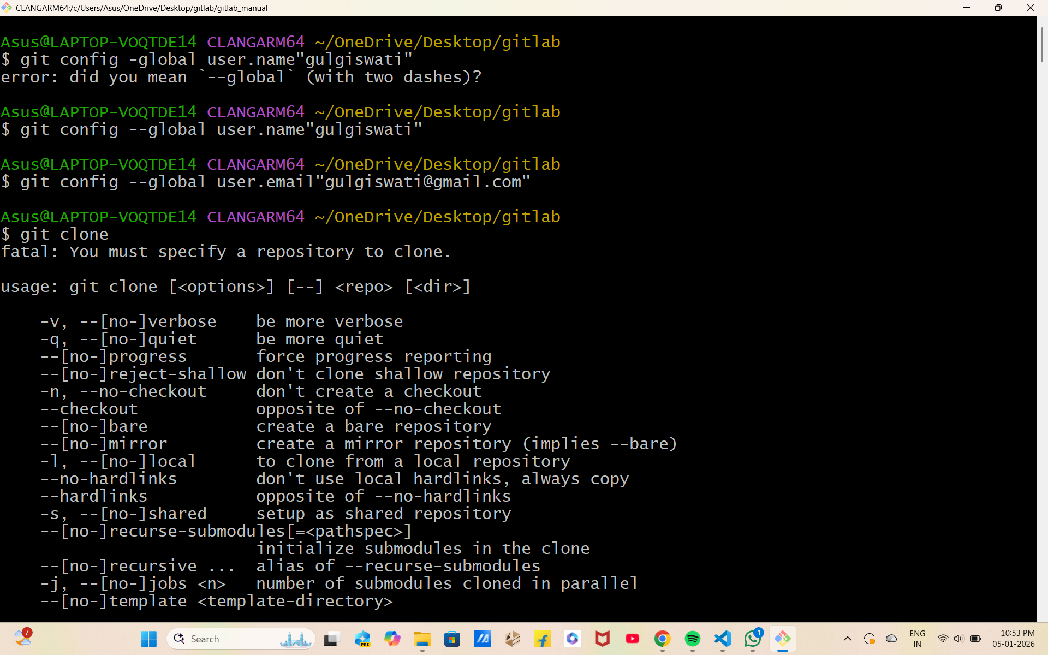
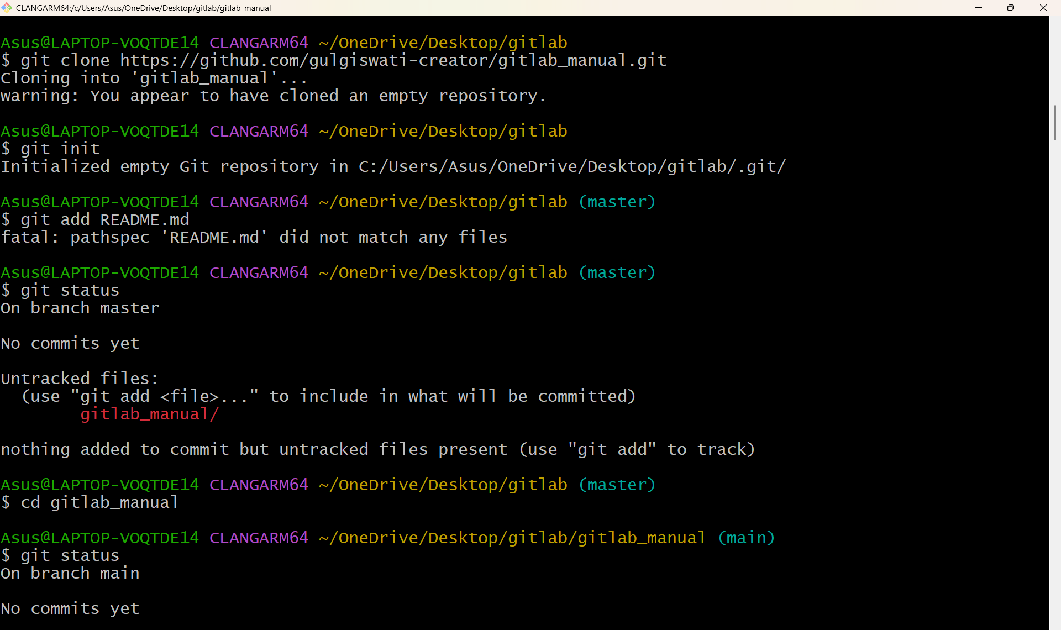
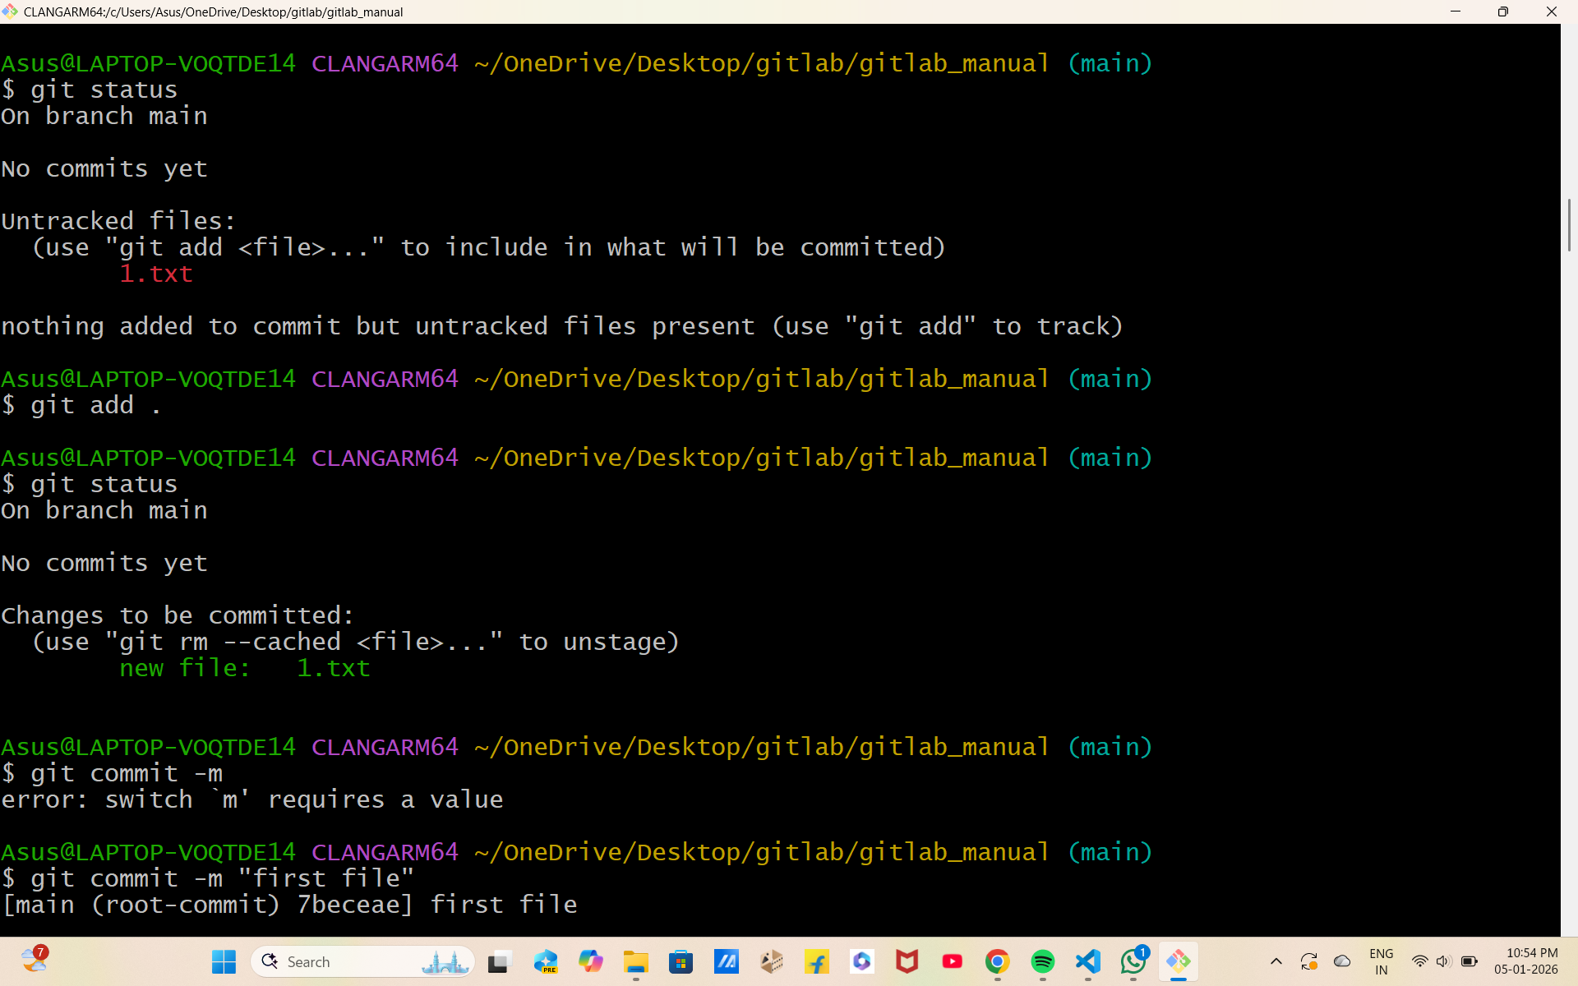
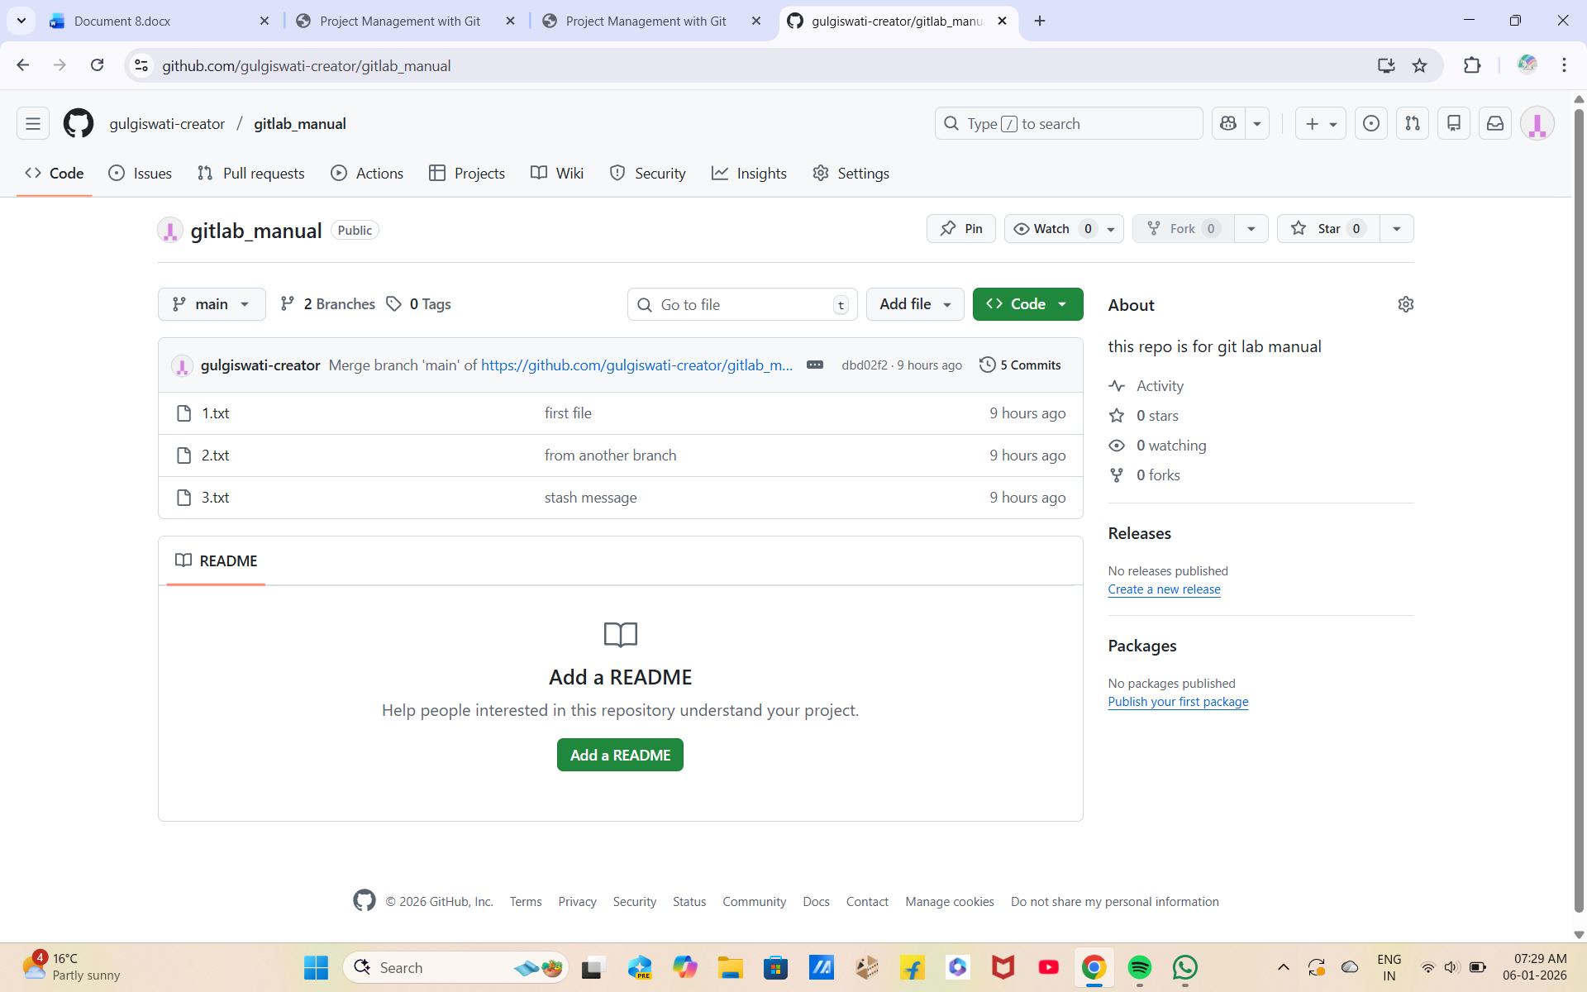

Exp2: Creating and Managing Branches Create a new branch named "feature-branch. " Switch to the "master" branch. Merge the "feature-branch" into "master. "
Solution: To create a new branch named "feature-branch," switch to the "master" branch, and merge the "feature-branch" into "master" in Git, follow these steps:
1. Make sure you are in the "master" branch by switching to it:
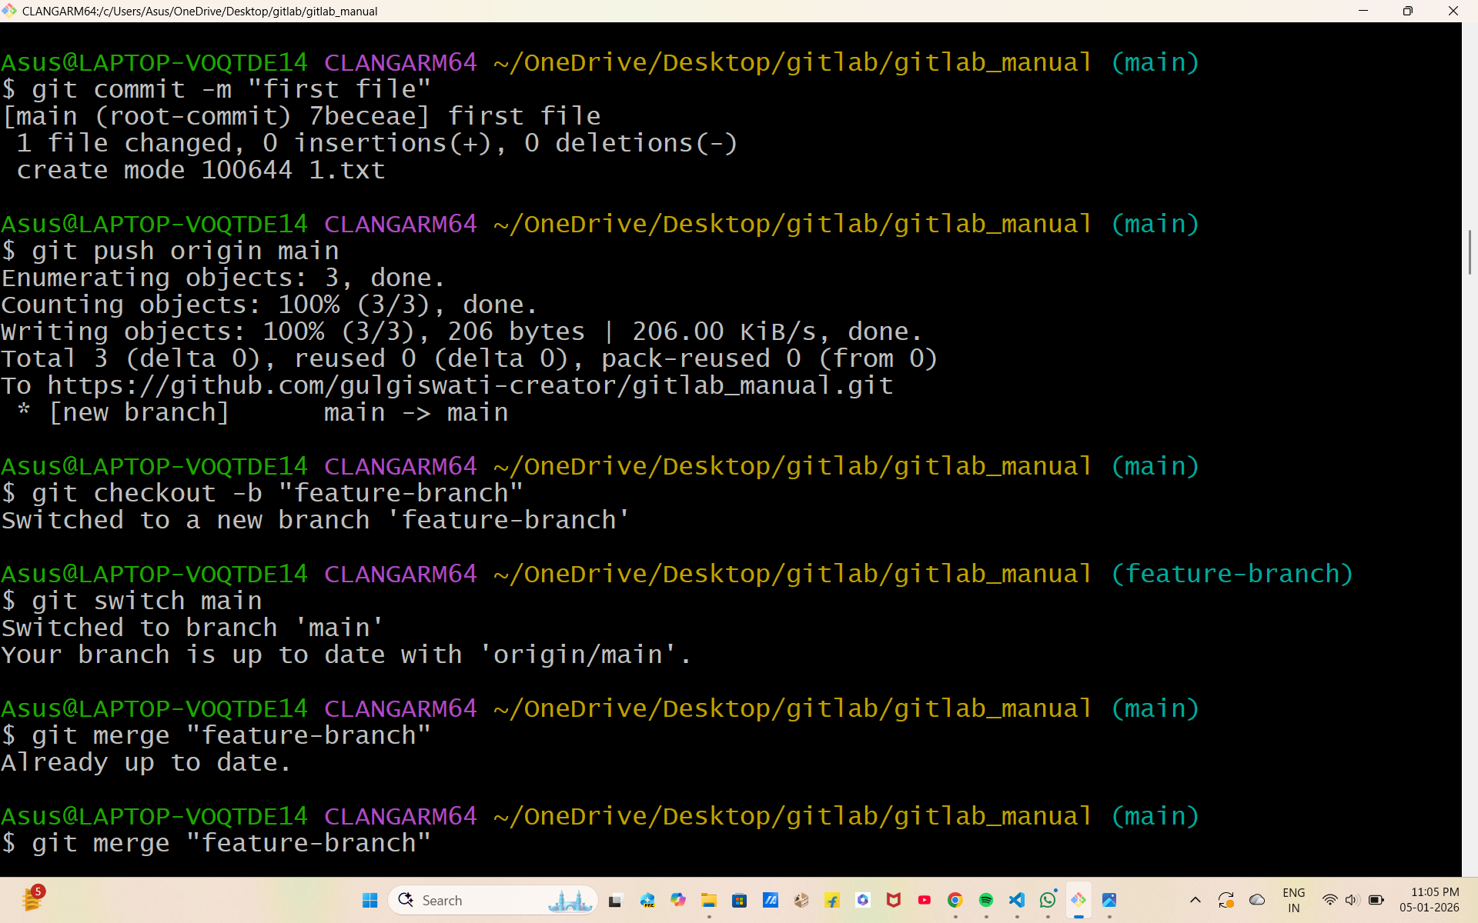
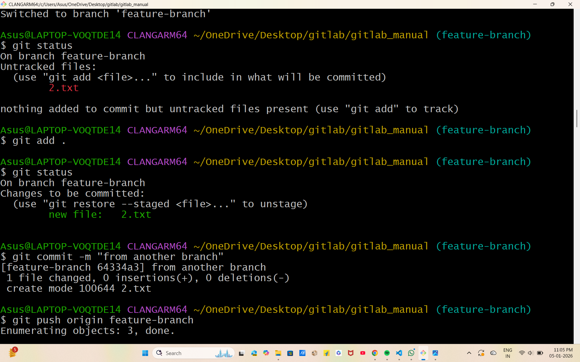

Experiment 3. Creating and Managing Branches: Write the commands to stash your changes, switch branches, and then apply the stashed changes.

Experiment 3. Creating and Managing Branches: Write the commands to stash your changes, switch branches, and then apply the stashed changes.
Solution: To stash your changes, switch branches, and then apply the stashed changes in Git, you can use the following commands:
1. Stash your changes:
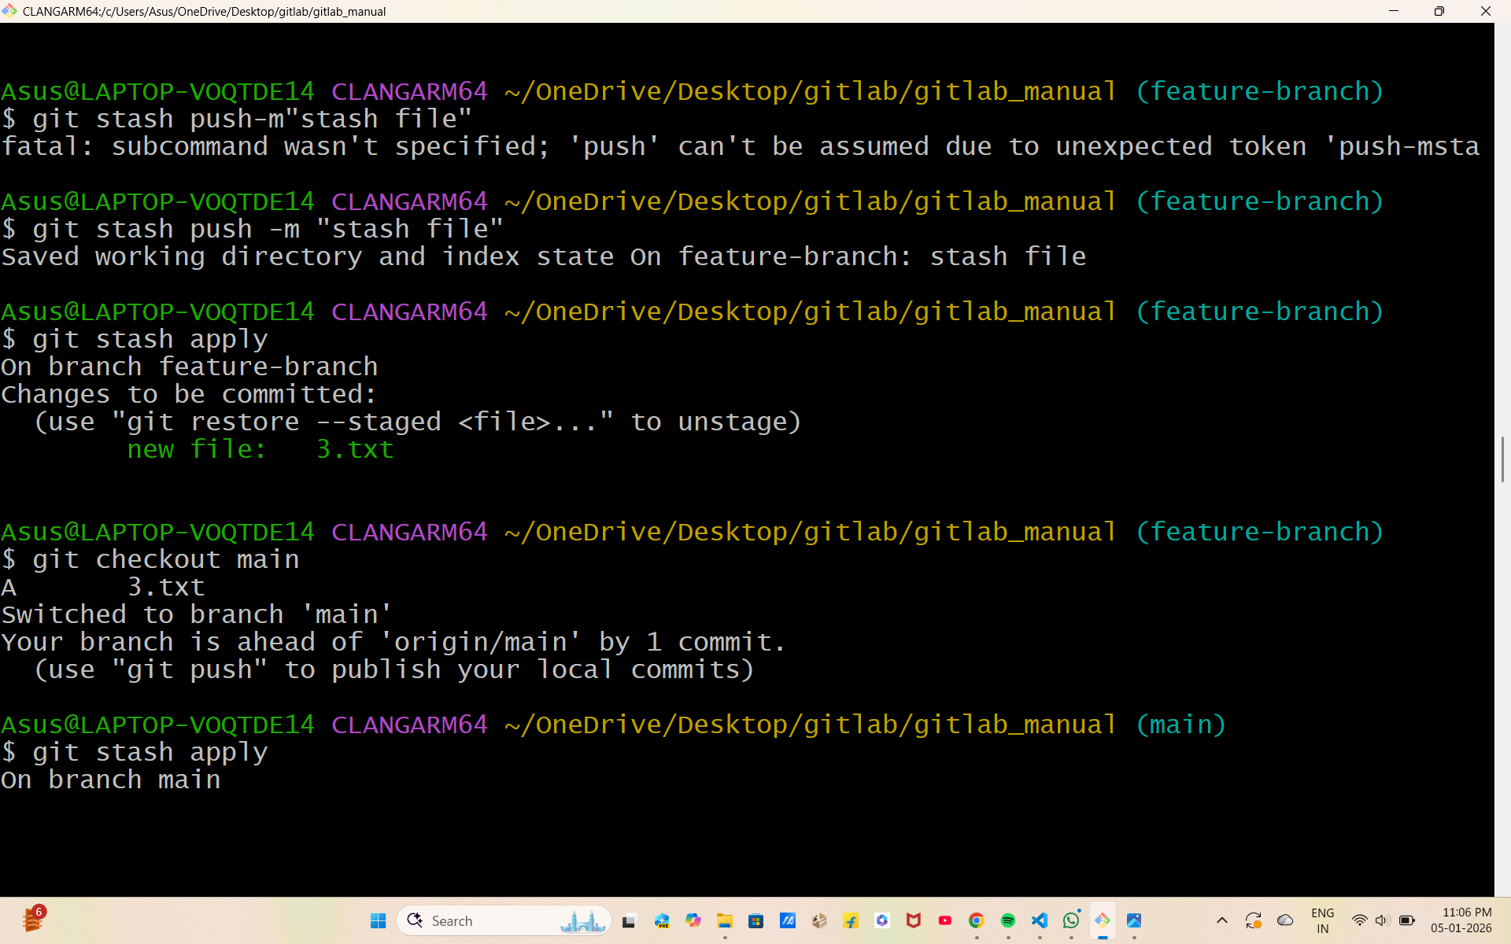
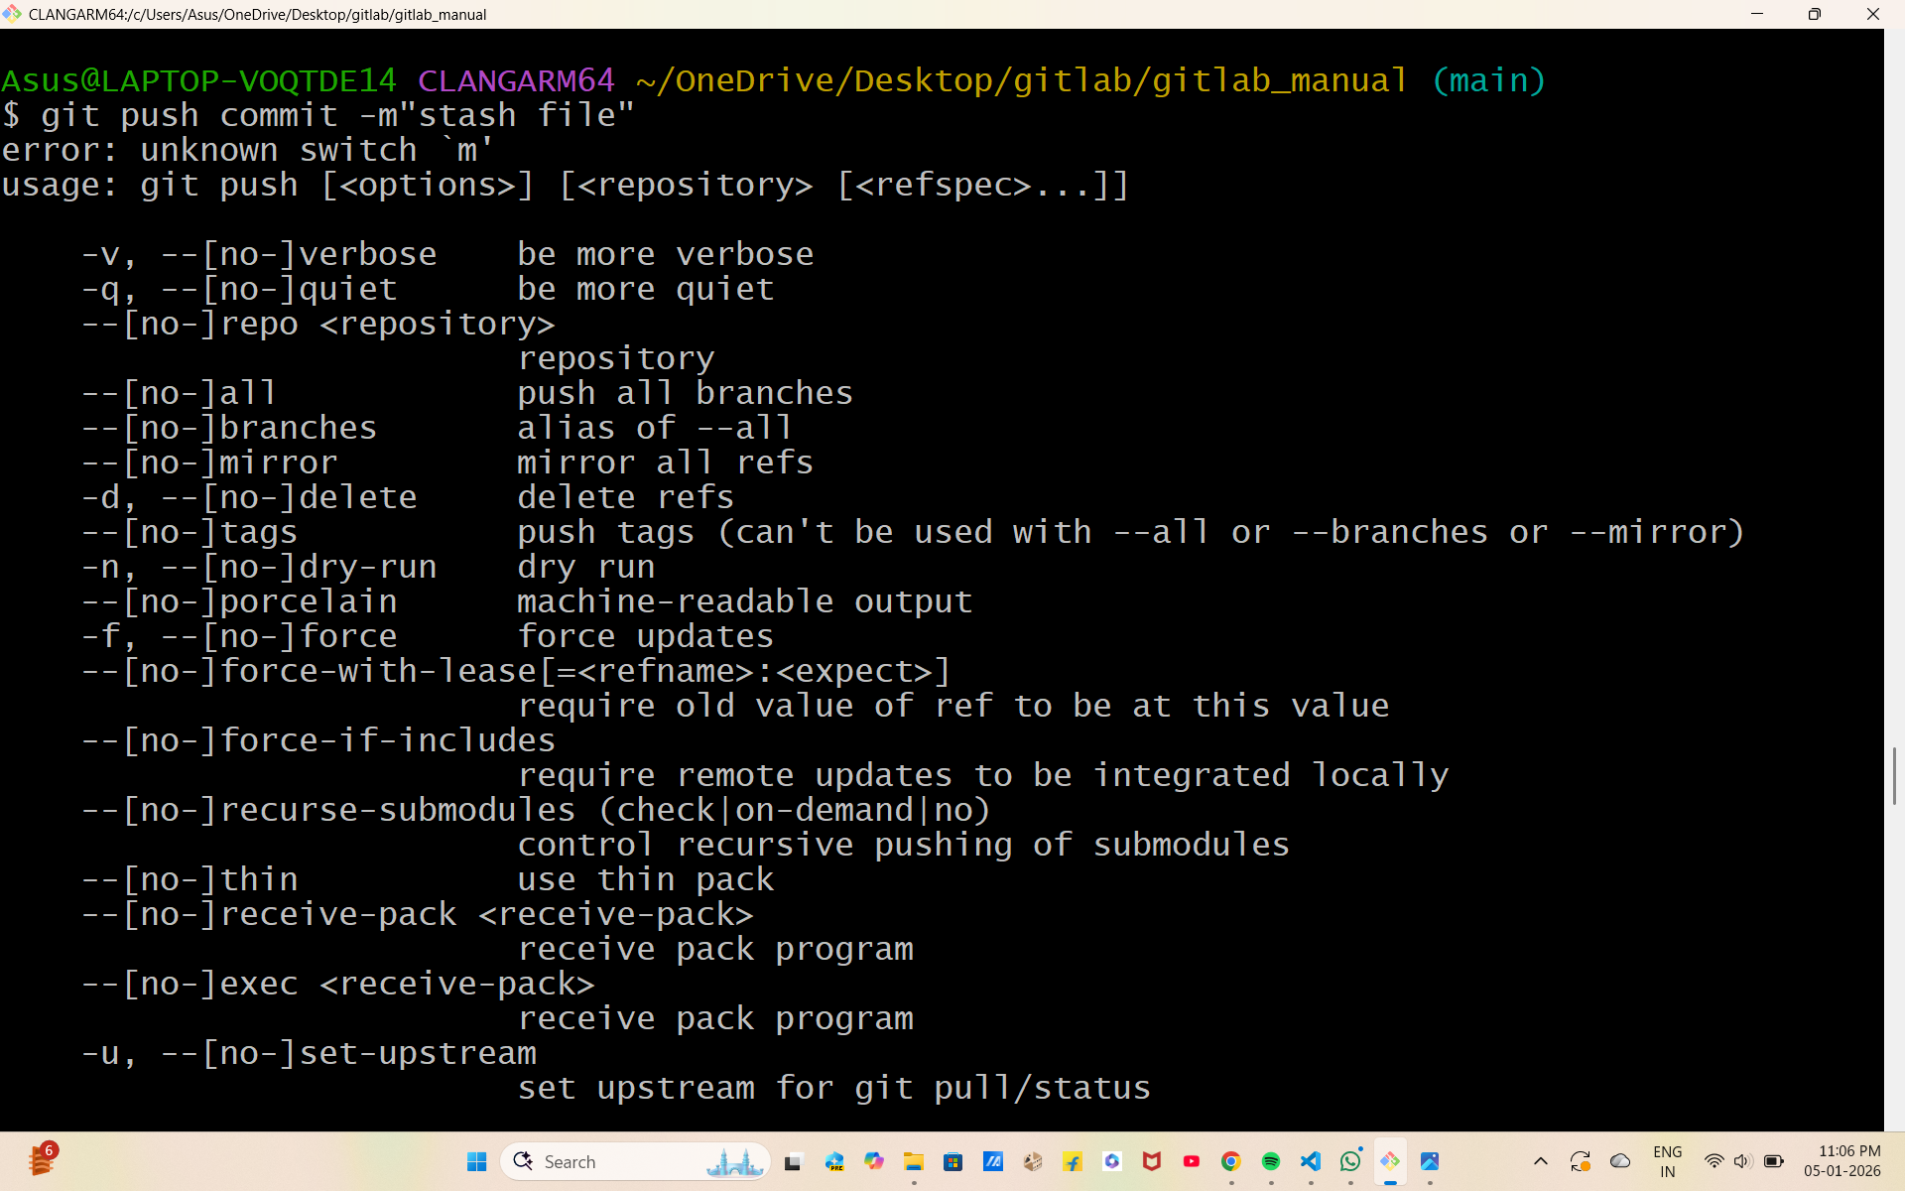

Experiment 4: Collaboration and Remote Repositories: Clone a remote Git repository to your local machine.
Solution: To clone a remote Git repository to your local machine, follow these steps: 1. Open your terminal or command prompt.
2. Navigate to the directory where you want to clone the remote Git repository. You can use the cd command to change your working directory.
3. Use the git clone command to clone the remote repository. Replace with the URL of the remote Git repository you want to clone. For example, if you were cloning a repository from GitHub, the URL might look like this

Experiment 5: Collaboration and Remote Repositories: Fetch the latest changes from a remote repository and rebase your local branch onto the updated remote branch.
Solution: To fetch the latest changes from a remote repository and rebase your local branch onto the updated remote branch in Git, follow these steps:
1. Open your terminal or command prompt.
2. Make sure you are in the local branch that you want to rebase. You can switch to the branch using the following command, replacing with your actual branch name:
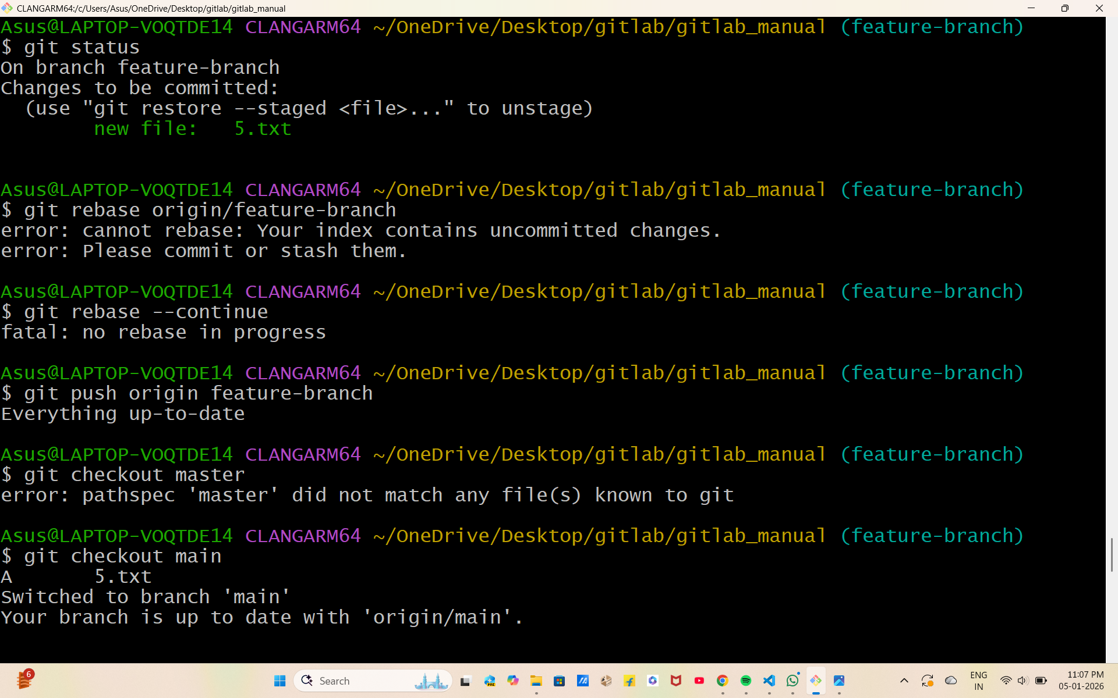

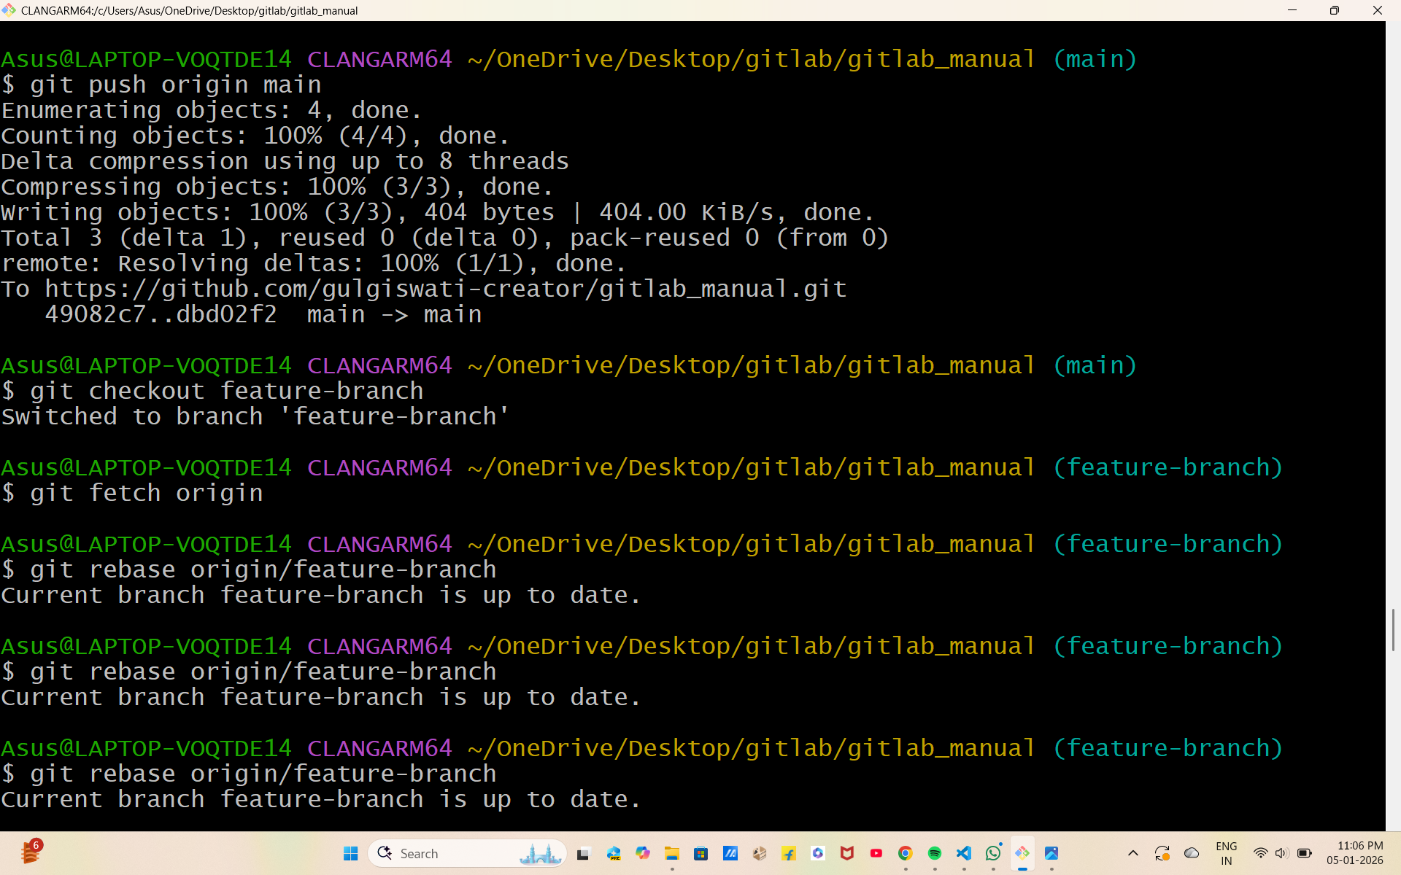

Experiment 6: Collaboration and Remote Repositories: Write the command to merge "feature-branch" into "master" while providing a custom commit message for the merge.
Solution: To merge the "feature-branch" into "master" in Git while providing a custom commit message for the merge, you can use the following command:
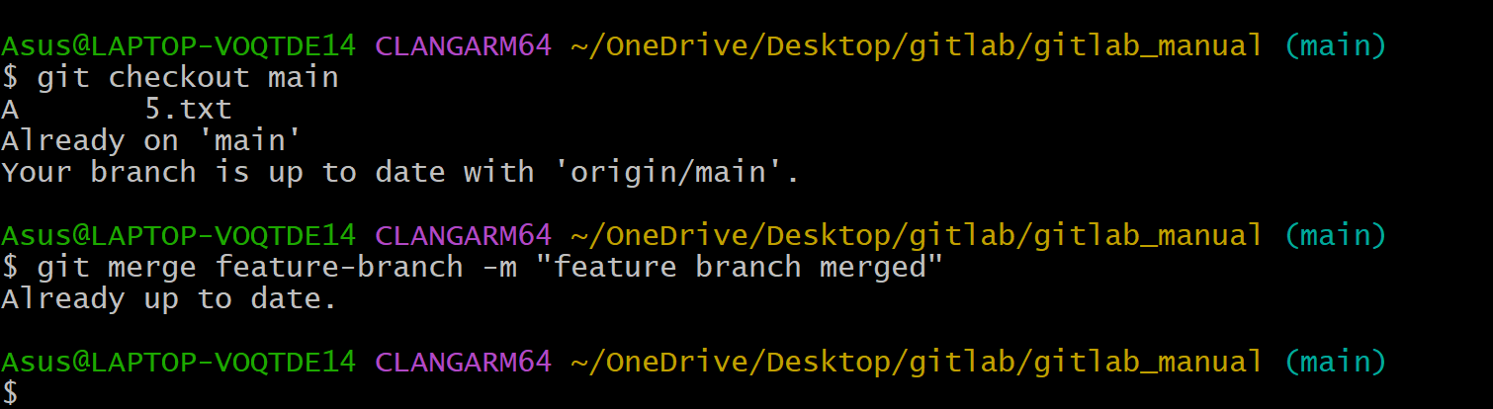
Experiment 7.
Git Tags and Releases: Write the command to create a lightweight Git tag named "v1.0" for a commit in your local repository.
Solution: To create a lightweight Git tag named "v1.0" for a commit in your local repository, you can use the following command:
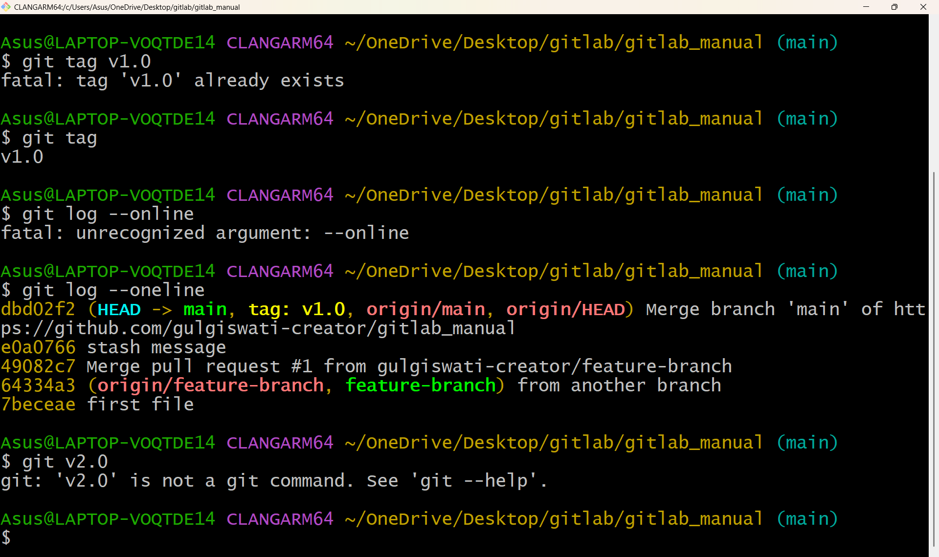

Experiment 8. Advanced Git Operations: Write the command to cherry-pick a range of commits from "source-branch" to the current branch
Solution: To cherry-pick a range of commits from "source-branch" to the current branch, you can use the following command:
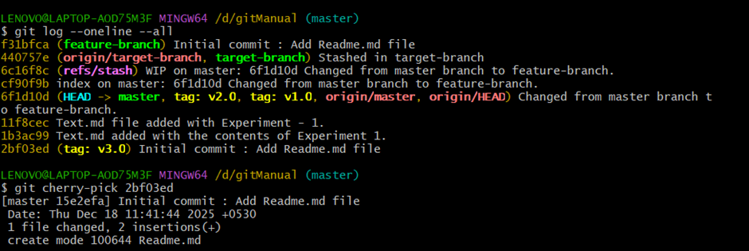

Experiment 9: Analysing and Changing Git History: Given a commit ID, how would you use Git to view the details of that specific commit,including the author, date, and commit message
Solution: To view the details of a specific commit, including the author, date, and commit message, you can use the git show or git log command with the commit ID. Here are both options:
1. Using git show: bash git show Replace with the actual commit ID you want to view. This command will display detailed information about the specified commit, including the commit message, author, date, and the changes introduced by that commit
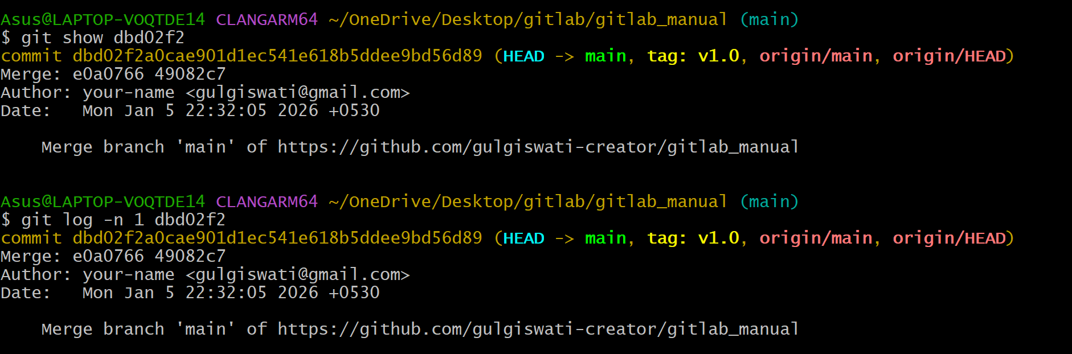

Experiment 10:Analysing and Changing Git History Write the command to list all commits made by the author "JohnDoe" between "2023- 01-01"and "2023-12-31."
Solution: To list all commits made by the author "JohnDoe" between "2023-01-01" and "2023-12-31" in Git, you can use the git log command with the --author and --since and --until options. Here's the command:
Experiment 11: Analysing and Changing Git History Write the command to display the last five commits in the repository's history.
Solution: To display the last five commits in a Git repository's history, you can use the git log command with the -n option, which limits the number of displayed commits. Here's the command:
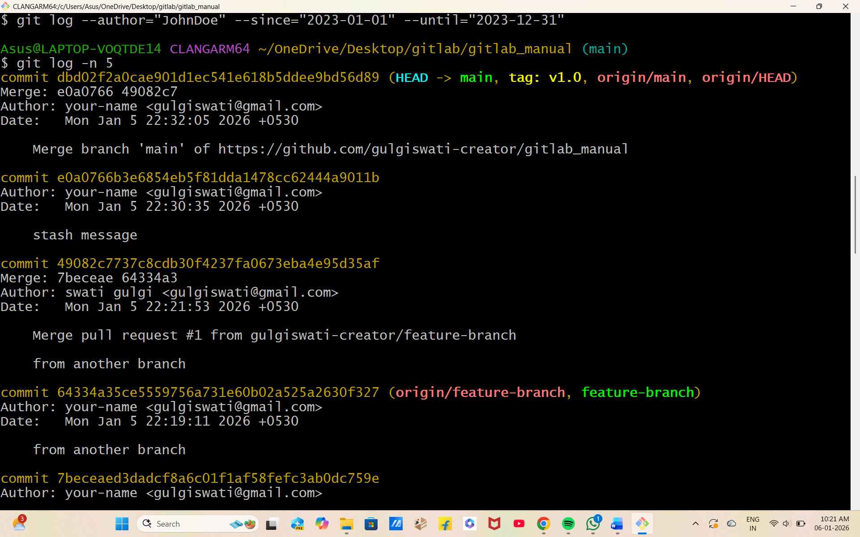

Experiment 12: Analysing and Changing Git History Write the command to undo the changes introduced by the commit with the ID "abc123".
Solution: To undo the changes introduced by a specific commit with the ID "abc123" in Git, you can use the git revert command. The git revert command creates a new commit that undoes the changes made by the specified commit, effectively "reverting" the commit. Here's the command:
